

MOHD. RAZIA
Sai Snehith
2520090149
CS&IT
CO-1

Case Study Topic: Content Metadata Indexing using AVL Tree in MediaVault

MediaVault stores thousands of digital contents such as movies, web series, podcasts, and videos. Efficient retrieval of content metadata is essential for providing fast search functionality to users.
An AVL Tree was implemented to store Content IDs and maintain a balanced indexing structure. This enables efficient searching and retrieval of content records even when the database grows significantly.

Problem Statement

MediaVault continuously receives new content uploads. If content records are stored using a normal BST, sequential insertions may create a skewed tree structure and increase search time.
The challenge is to:
- Maintain balanced indexing.
- Improve content retrieval speed.
- Support efficient insertion and searching.
- Handle large content repositories.
Proposed Solution

Use an AVL Tree to store Content IDs.

Implementation Details:

Algorithm Used

AVL Tree

Operations Performed

Insert Content IDs.

Perform AVL rotations.

Search content records.

Display final AVL Tree.

Perform inorder traversal.

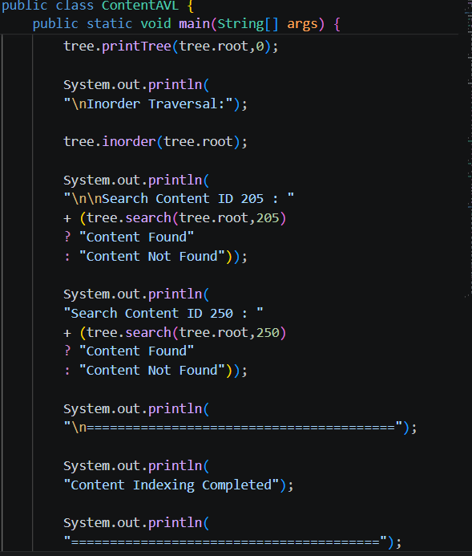

Result: Screenshots/Output

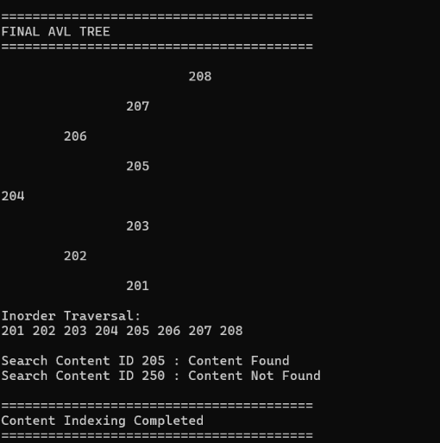

- AVL Tree maintained balance successfully.
- Content retrieval was efficient.
- Rotations prevented tree skewness
GitHub Link:

https://github.com/snehiths399-byte/MediaVault--Digital-content-streaming-and-Analytics-system

